Steps to use Synapse Best Practice Report

1. Install Latest version of [Power BI Desktop App from Microsoft Store](https://aka.ms/pbidesktopstore).

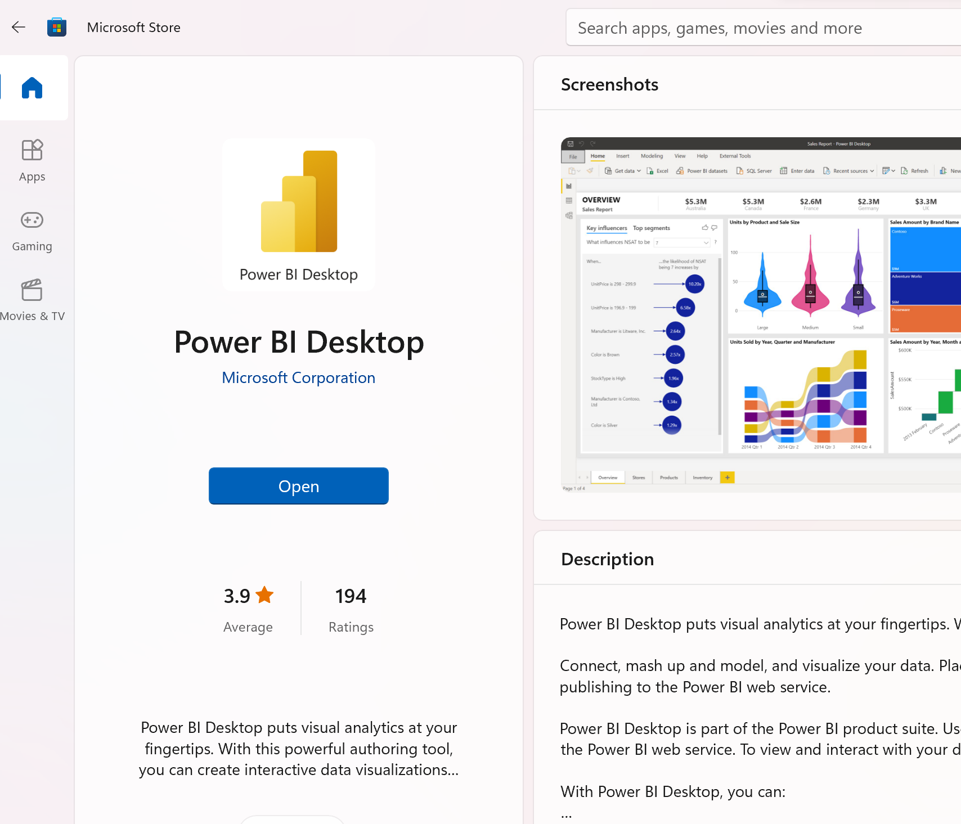

1. Once installed open Power BI Desktop on your PC.
2. It will prompt you for Get Data screen. You can click on Open other reports link

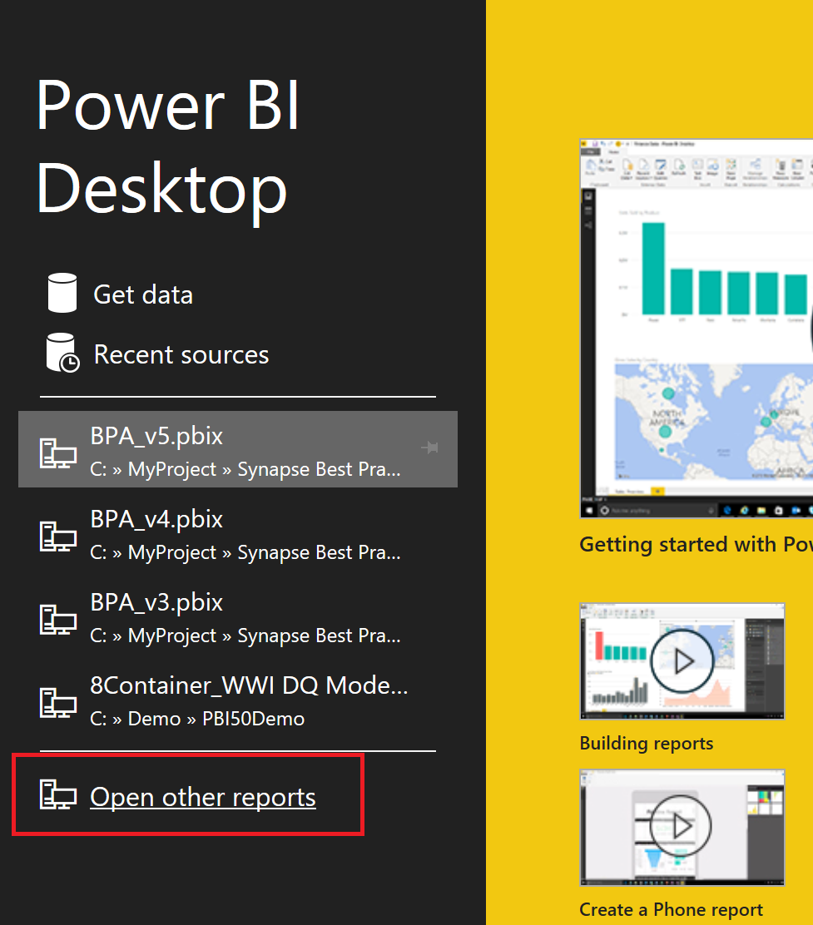

1. Change file type from pbix to pbit (1)
2. Select “Synapse Best Practice Report.pbit” template file provided (2)

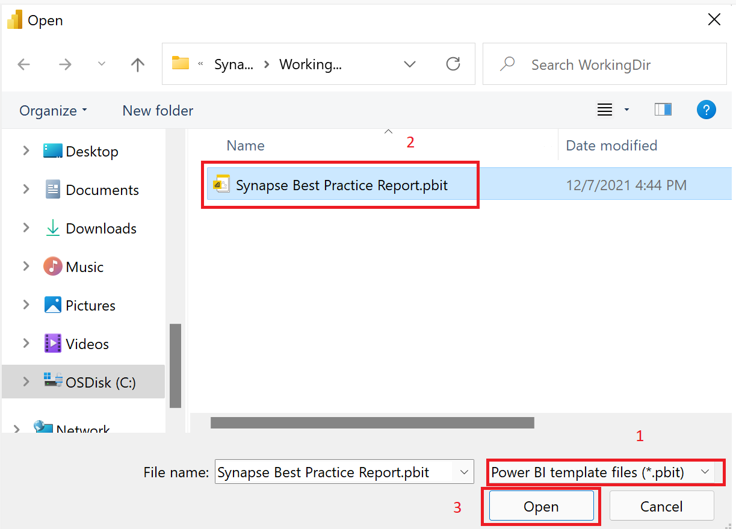

1. Click open (3)
2. Dialogue box for Synapse Best Practice report will open

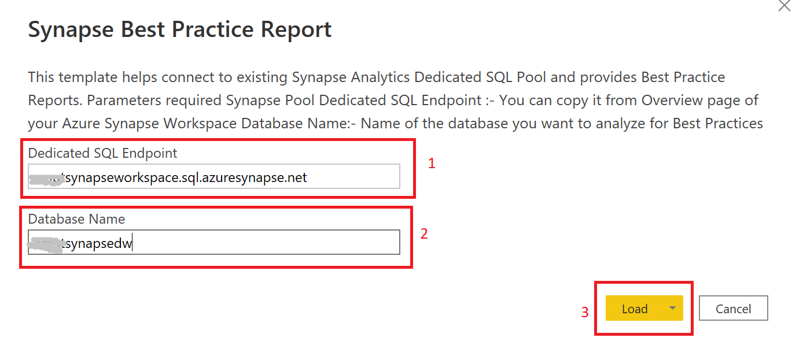

1. Provide Synapse Dedicated Pool Endpoint (1) and Database Name (2) in the parameter text boxes
2. Click Load to open report (3)
3. If you are opening it for the first time it will pop up security warnings. This is because most of the data is collected using native database queries against DMVs. You need to allow each one permission to run by hitting 'Run' on the popup. Like an example below

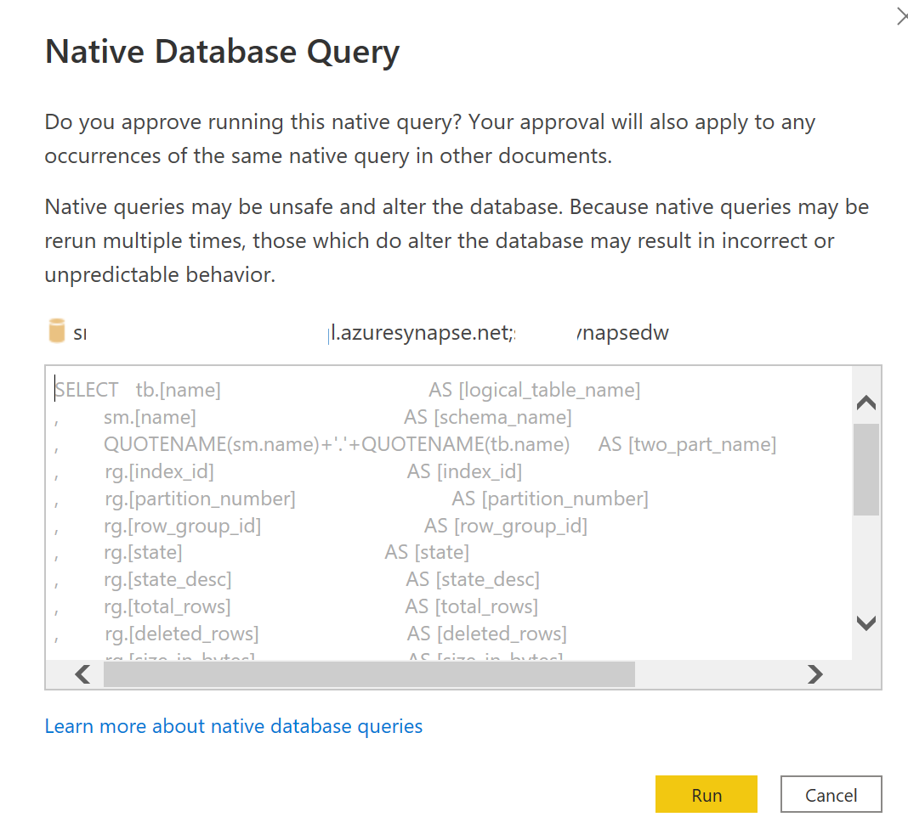

1. Click “Try Again” to allow it to connect to Synapse Endpoint through Native Query.
2. This should start the refresh process.
3. Once refresh is complete click OK

